

Indian Institute of Technology, Kharagpur

Database Management System Lab

2022-23

Atishay Jain

20CS30008

Assignment -1
E-R diagram to capture the logical data organization for the COVID-19 tracking system
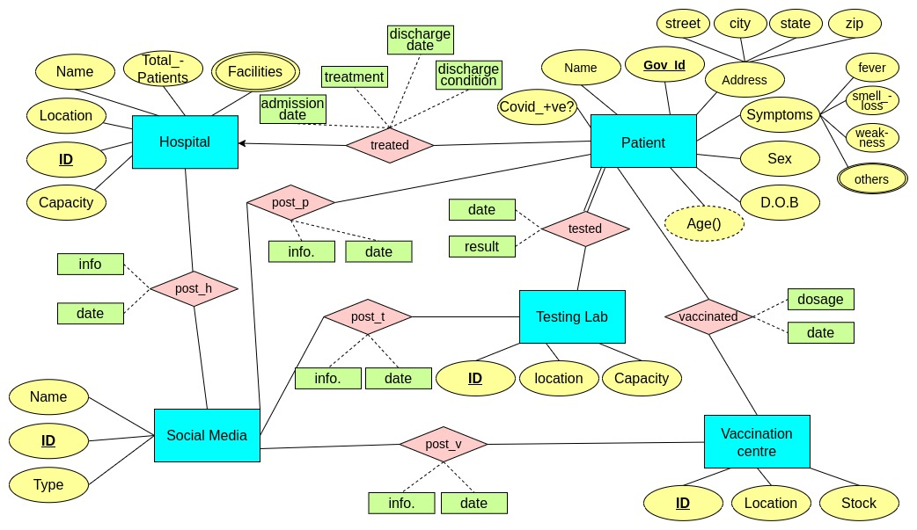
The entities in the schema are described below:

- Patient: This stores the information of person that get himself tested/ admitted/ vaccnated in/ form Testing Lab/ Hospital/ Vaccination Centre. The patient entity has various attributes that give some information about the person and help in keeping the record. Covid_+ve? attribute specifies the variant if testef positive or holds null value.
- Hospital: This entity stores the information about a hospital. It contains attributes like facilities, capacity for easy administraion. Facilities is a multi-valued attribute.
- Testing Lab: This entity is used to store the information of a Covid testing lab. It contains location and capacity attributes to help in administrative decision.
- Vaccination Centre: This entity represent a vaccination centre’s informatin. It contain the stock attribute to help in delivering the required amount of vaccine.
- Social Media: This entity represents the different kind of social media’s inforamtion. The type attribute tells about the mode of operation of the social media like TV, internet, etc.

Now, the relations shown in the E-R diagram are explained below:

- treated: It tells the hospital in which the patient is admitted. It contains attributes like treatment, discharge date, discharge condition to help the health specialists in juding the treatment. Many patients can be treated in the same hospital, but a patient will remain admitted in one hospital only.
- tested: It specifies the testing lab where the customer can get his Covid-test done. It contains the attribute location to know which area are more affected. A person can get himself tested in multiple Testing Labs and a testing lab can test multiple people. Everyone who is present in the database is tested in some database.
- vaccinated: It tells the vaccination centre where the patient will get vaccinated. It contains the attribute dosage to know which dose has the patient taken. A patient can take diffterent doses from different Vaccinatino Centres and a vaccination centre will serve multiple patients.
- post: This is a relation between the social media and the other entities. Socail media shares some information about a hospital/ testing centre/ patient on some date. A post contains the attributes information and the date of posting. A social media platform can share information about multiple hospitals/ vaccination centres. Also, the same hospital/ patient can be shown in different social media.

The relational tables will look like:
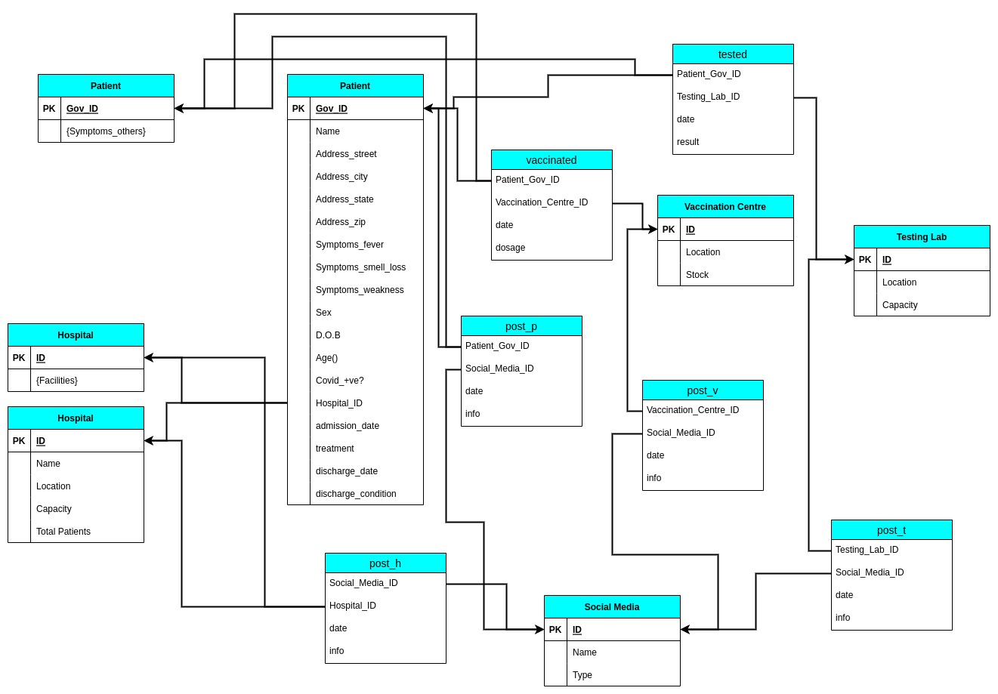

Various features can be perfomed in the following way:

- reporting the prevalence and progress of pandemic with time, among various patient profiles, geographical units like districts and states: We can see the location of the testing labs where more patients are coming from. Also we can see the symptoms of those patients. Thus we have various patient profiles and the effect of various treatment on them.
- tracking symptoms and variants that are currently common : We have the symptoms attribute in the patient entity. We can see the symptoms of patients that are tested positive recently only. Hence, we can track the symptoms and variants that are currently common.
- use of healthcare resources and inventory management for future readiness: We have the capacity, facilities and stock attributes in different entities which tell us about the resources that we have. In more prone are, we can increase the capcity, facilites and doctors in the hospital and vaccination centres. In less prone areas, we can increase the testing capacity.
- contact tracing: We are storing the location of every patient. So we can trace the possible contacts that an infected person can make and take the required precautions.
- other functionality: We can see the posts on the social media which may be detailing about the actual conditions of the healthcare infrastructure and take the required actions.

